Health and Safety

Some materials, tools and equipment can be dangerous if used inappropriately or without due care. Pupils need to be given clear instructions and demonstrations regarding the correct and proper use of certain tools, media and equipment. Teachers should ensure that safe distribution, collection and storage of dangerous items are organised within the art room. Safety rules should be clearly displayed and adhered to by pupils. Pupils must be supervised closely when using sharp tools or hazardous materials such as glazes or chemicals e. g. enamels. Manufacturers’ instructions must always be followed closely.

All pupils should be encouraged to develop good workmanship skills, whereby their work area is kept clean and tidy as their work progresses. Schoolbags should be placed under tables to provide clear access around the art room. Ties should be tucked inside the shirt or removed, if there is any risk of entanglement with equipment.

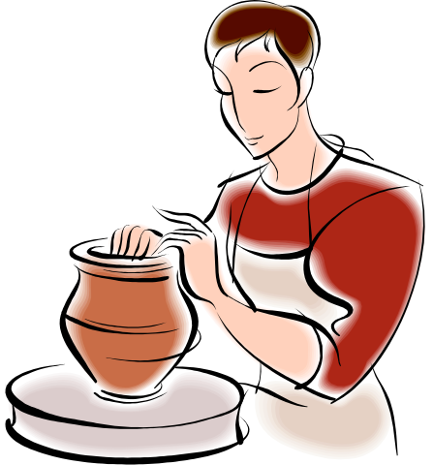

Ceramics Studio

The kiln must be situated in a separate room from the general art room. Pupils must not have access to the kiln during the firing process. Extraction fans should be in operation when there is a high level of dust from dried clay and also during the use of spray guns for glazing bisque ware.

